Developing your understanding 16.2

1 Define ‘dynasty’.

2 Explain what oracle bones were and how they were used.

3 What artefacts characterised the economy of the Shang dynasty?

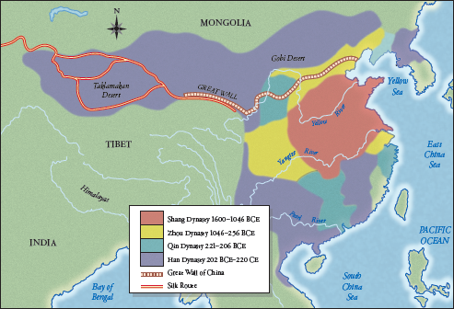
Source 16.3 Map showing extremities of the four early dynasties in China, the original Great Wall and the early
Silk Route

4 Consider the information provided so far, especially by Source 16.3. Use your computer (or the school’s computer) to make a timeline of the period covering the Xia, Shang and Zhou dynasties. Describe key developments of these periods including oracle bones, bronzeware and Chinese schools of philosophy.
To help you with your design, find the link to the Tiki Toki website at www.cambridge.
edu.au/hass7weblinks. This is a free website, and will allow you to incorporate illustrations to demonstrate aspects or features of these dynasties, such as oracle bones.

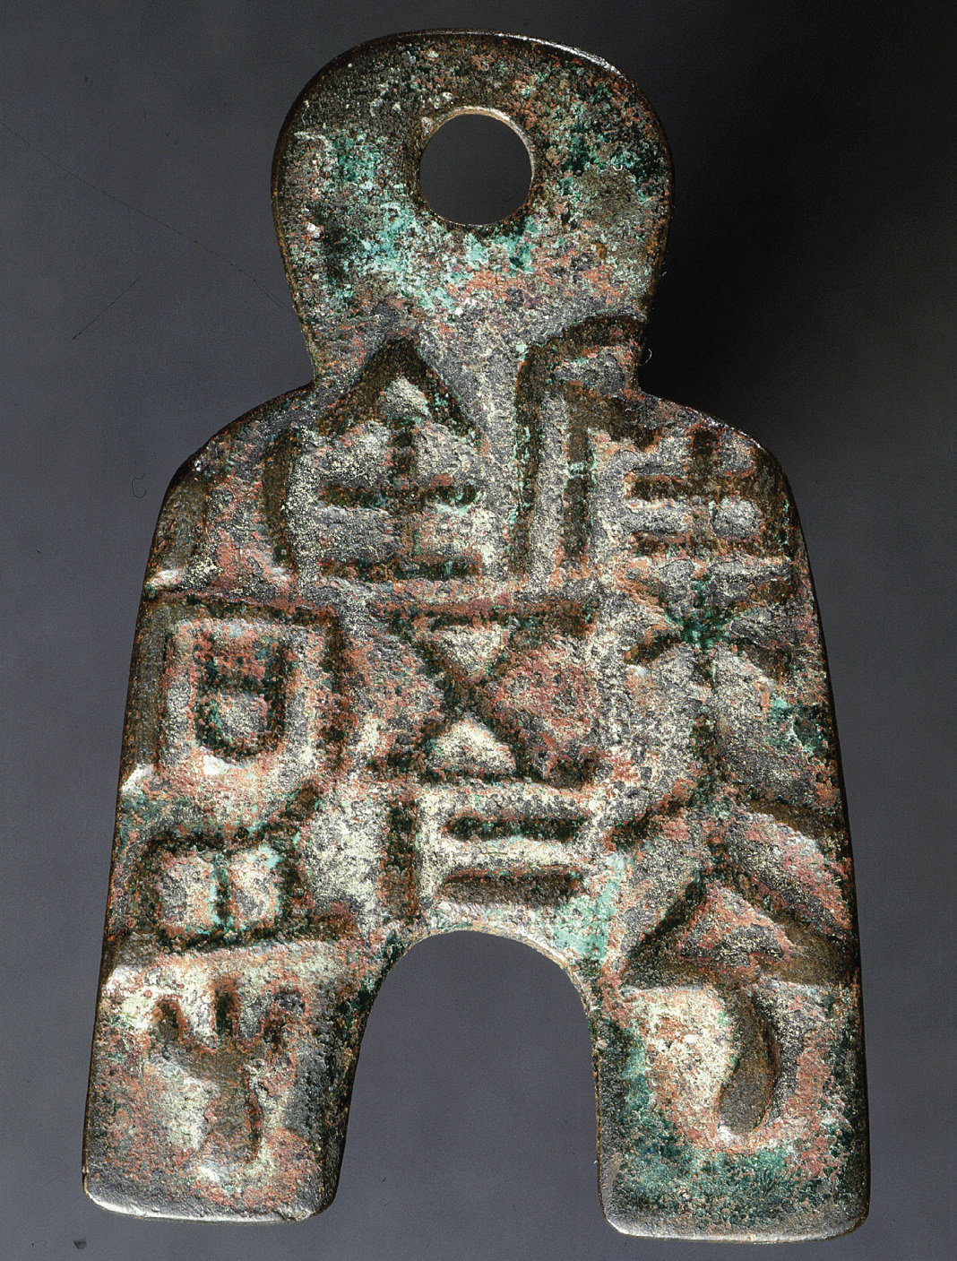
Source 16.6 The earliest Chinese coins were made in the shape
of miniature hoes, spades and knives. They were probably first
issued around the tenth century bce and continued in use during
the Zhou period. Flat-handled spade coins (shown here) made
from copper appeared around 300 bce.

5 Source 16.6 shows an example of coinage introduced during the Zhou period. Why do you think they were shaped like this?

